**Refund in Shopify store**

**Go to your store.**

**Under „Orders“ you can find all sales and those you need to refund or cancel.**

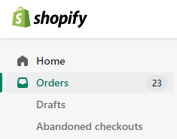

**Click on the order you need to refund. Click on refund.**



**Put in the amount of items you need to refund, partially or all. Write a reason for refund. Press Refund to confirm.**

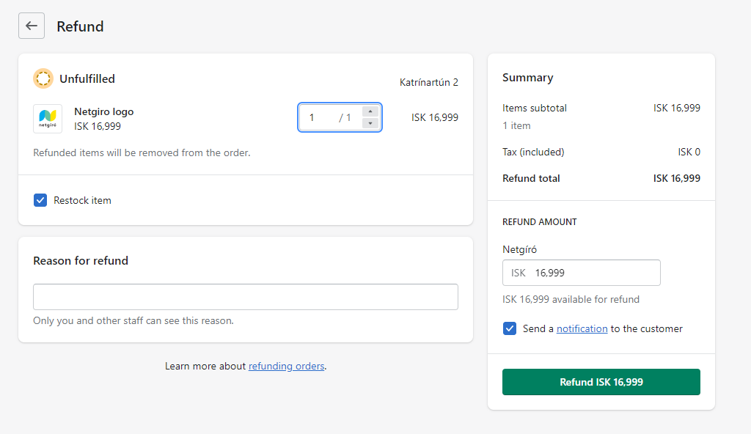

**Order has now been refunded.**

